Eight Puzzle

Programmer*: Cuyler Warnock*

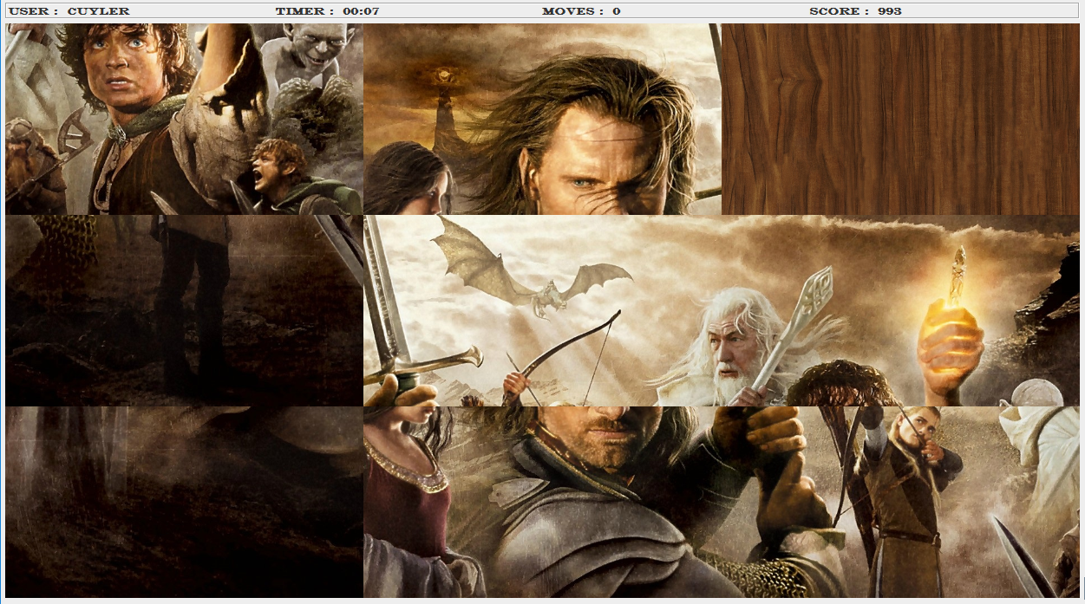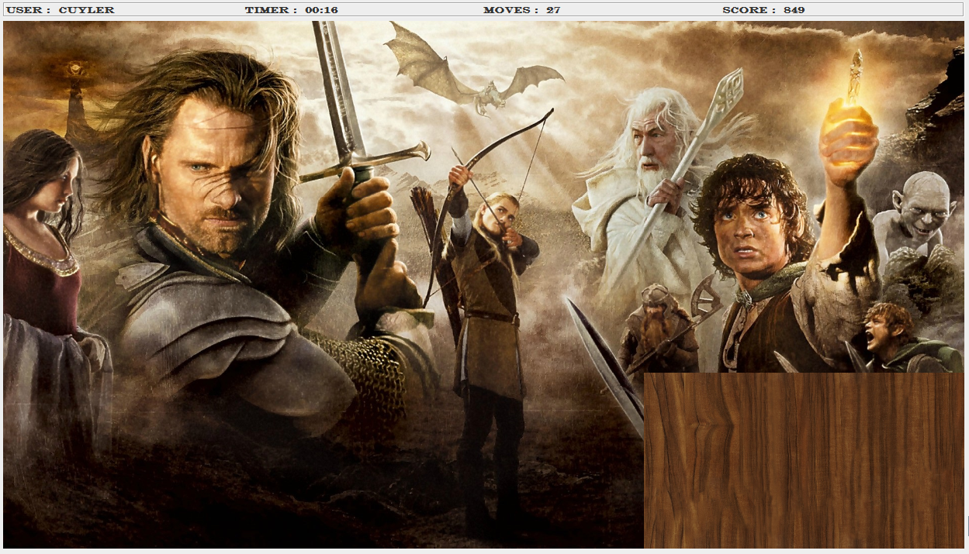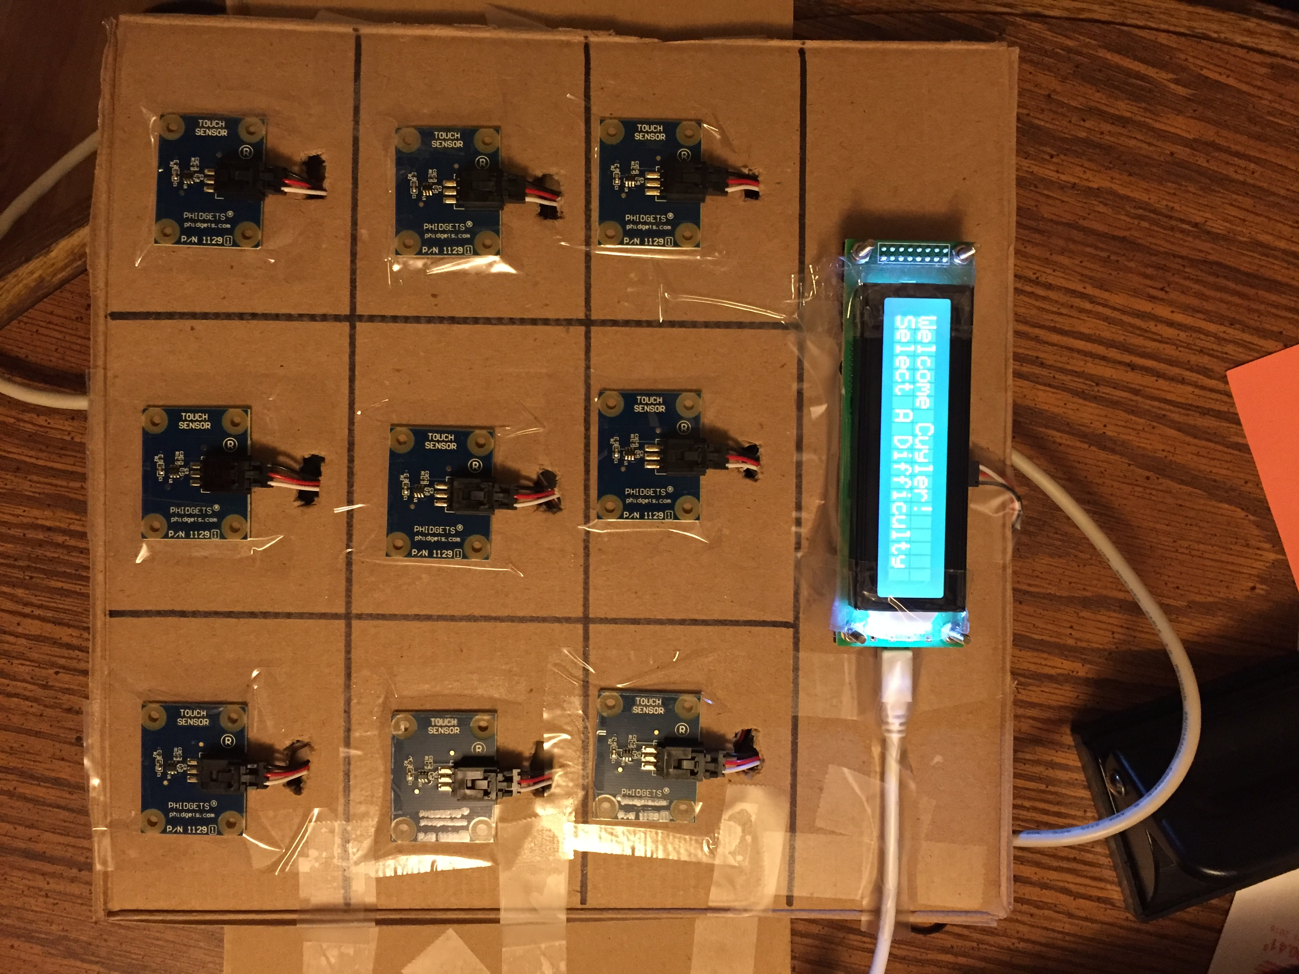

**Description:** In Eight Puzzle, you are given a scrambled picture with an empty space located somewhere on the grid. The goal is to rearrange the images by sliding them into the empty space so that the picture is eventually back to its original form with the empty space in the bottom right. You may slide the images by pressing the corresponding touch sensor of the image that is beside the empty space. The image will then slide into the empty space. Repeat this process until the picture is back in its original form. I also used a LCD display to display instructions.

**List of Phidgets used:**

* Touch Sensors
* LCD Interface

**List of Programming Features learned in CSCI 1302**

* Static Methods and Fields
* Inheritance and Aggregation
* Exception Handling
* GUI: JFrame, JLabel, JPanel, JButton, JRadioButton, Color, Font, Layouts, Borders, Images
* Listeners: ActionListener, ItemListener, WindowListener, SensorChangeListener